Photoelectric Effect: New Features

9/14/06
The following features have been requested to be available by the beginning of the spring semester.

Vertical Zoom for Graphs
Vertical zoom controls will be added to each of the graphs. The controls will be visually and functionally the same as those in the Fourier Transform simulation. Room will be made to the right of the existing graphs by taking away equal amounts of space on either side of the objects in the play area. Note that the controls shown in the mock-up below are smaller than those in the Fourier simulation, but are a size more appropriate to this simulation.

Graph Snapshots
Users will be able to take snapshots of individual graphs, using a control next to the graphs similar to those in the Hydrogen Atom simulation. Each snapshot will appear in a floating, movable window.

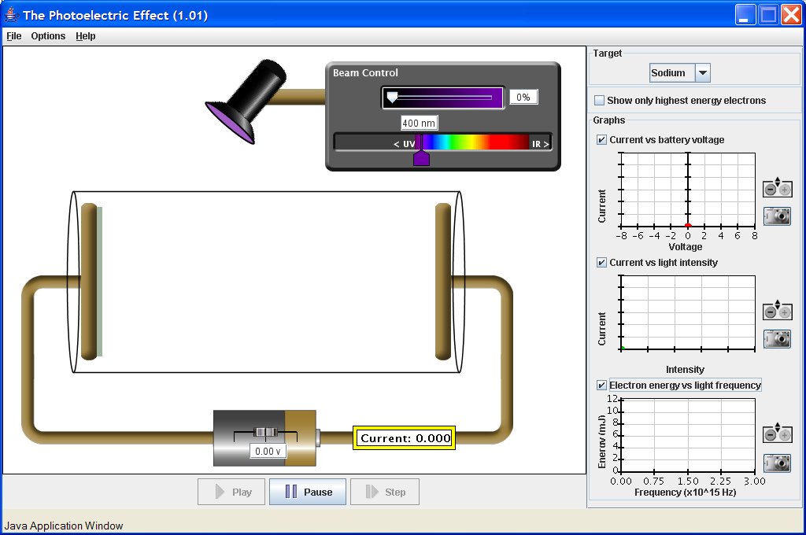

Change UV and IR Indicators in the Wavelength Control
Danielle’s interviews indicate that the “< UV” and “IR >” indicators in the wavelength control are a bit confusing to some users. The problem seems to be with the “<” and “>” characters, used as arrows. It has been requested that they be replaced with proper arrows. Chris Malley has suggested that we just remove the “<” and “>” characters, and center the “UV” and “IR” labels in their respective gray areas. This will be less work, and probably be just as effective.

